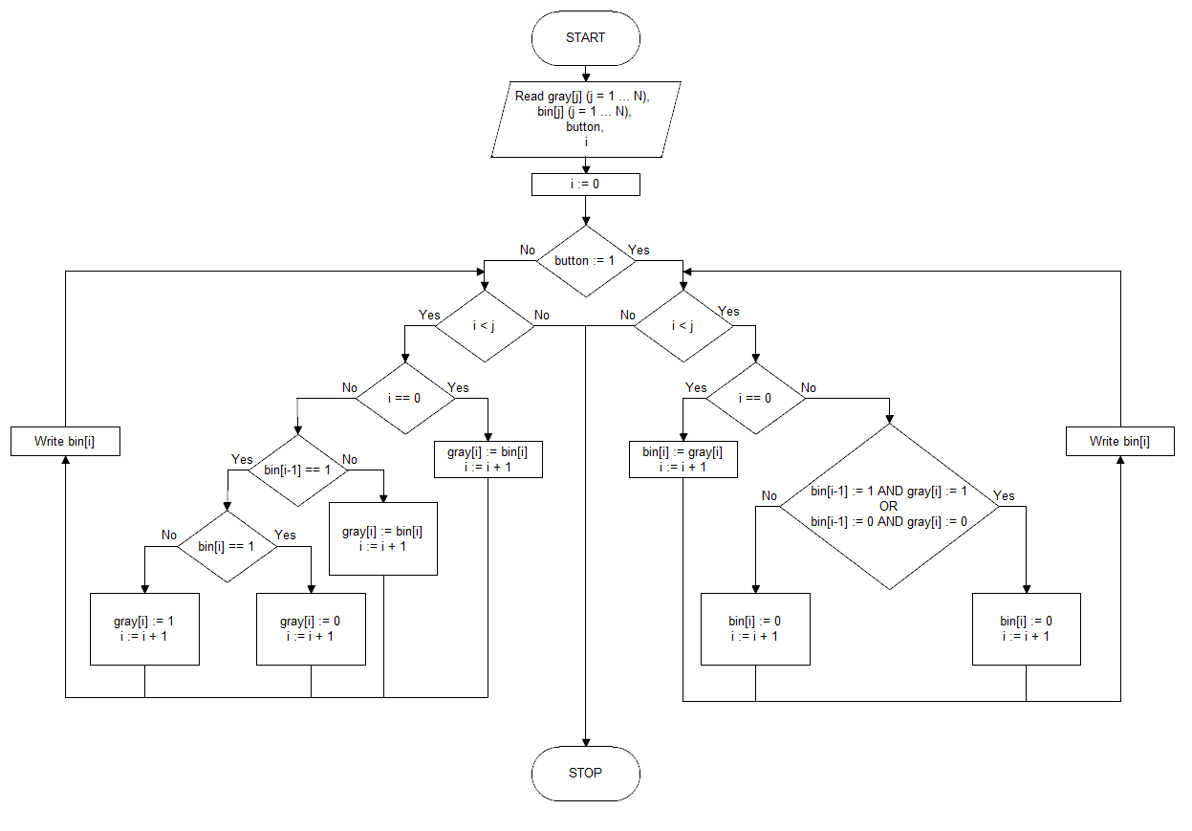

**Pseudocode**

**Start**

**Read** gray[j] (j = 1 … N), bin[j] (j = 1 … N), button, i

i := 0

**if** button == 1 **then**

**Repeat**

**if** i == 0 **then**

bin[i] := gray[i]

i := i + 1

**otherwise**

**if** (bin[i-1] == 1 **AND** gray[i] := 1) **OR** (bin[i-1] == 0 **AND** gray[i] := 0)

bin[i] := 0

i := i + 1

**otherwise**

bin[i] := 1

i := i + 1

**Write** bin[i]

**Until** i < j

**Otherwise**

**Repeat**

**if** i == 0 then

gray[i] := bin[i]

i := i + 1

**otherwise**

**if** bin[i-1] == 1 **then**

**if** bin[i] == 1

gray[i] := 0

i := i + 1

**otherwise**

gray[i] := 1

i := i + 1

**otherwise**

gray[i] := bin[i]

i := i + 1

**Write** gray[i]

**Until** i < j

**Stop**